CS 255 System Design Document

This template lays out all the different sections that you need to complete for Project Two. Each section has guidance to prompt your thinking. You will need to continually reference the interview transcript as you work to make sure that you are addressing your client’s needs. There is no required length for the final document. Instead the goal is to complete each section based on what your client’s needs are. Remove this note when you are finished, and replace all bracketed text with the relevant information.

UML Diagrams

UML Use Case Diagram
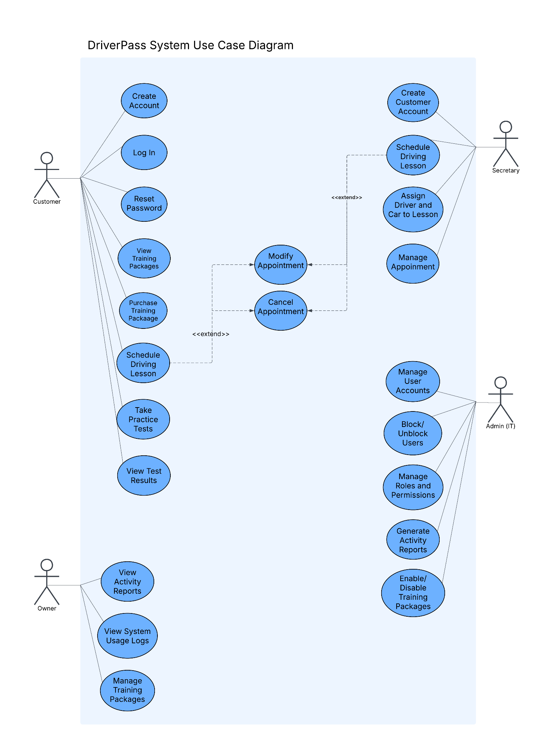

UML Activity Diagrams
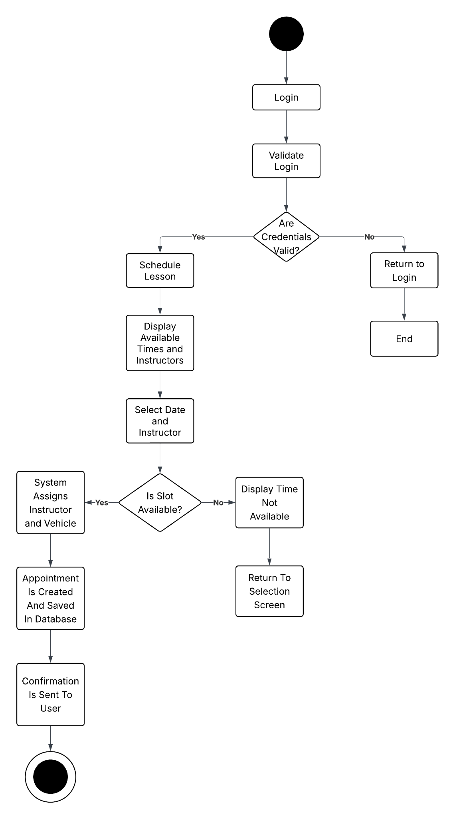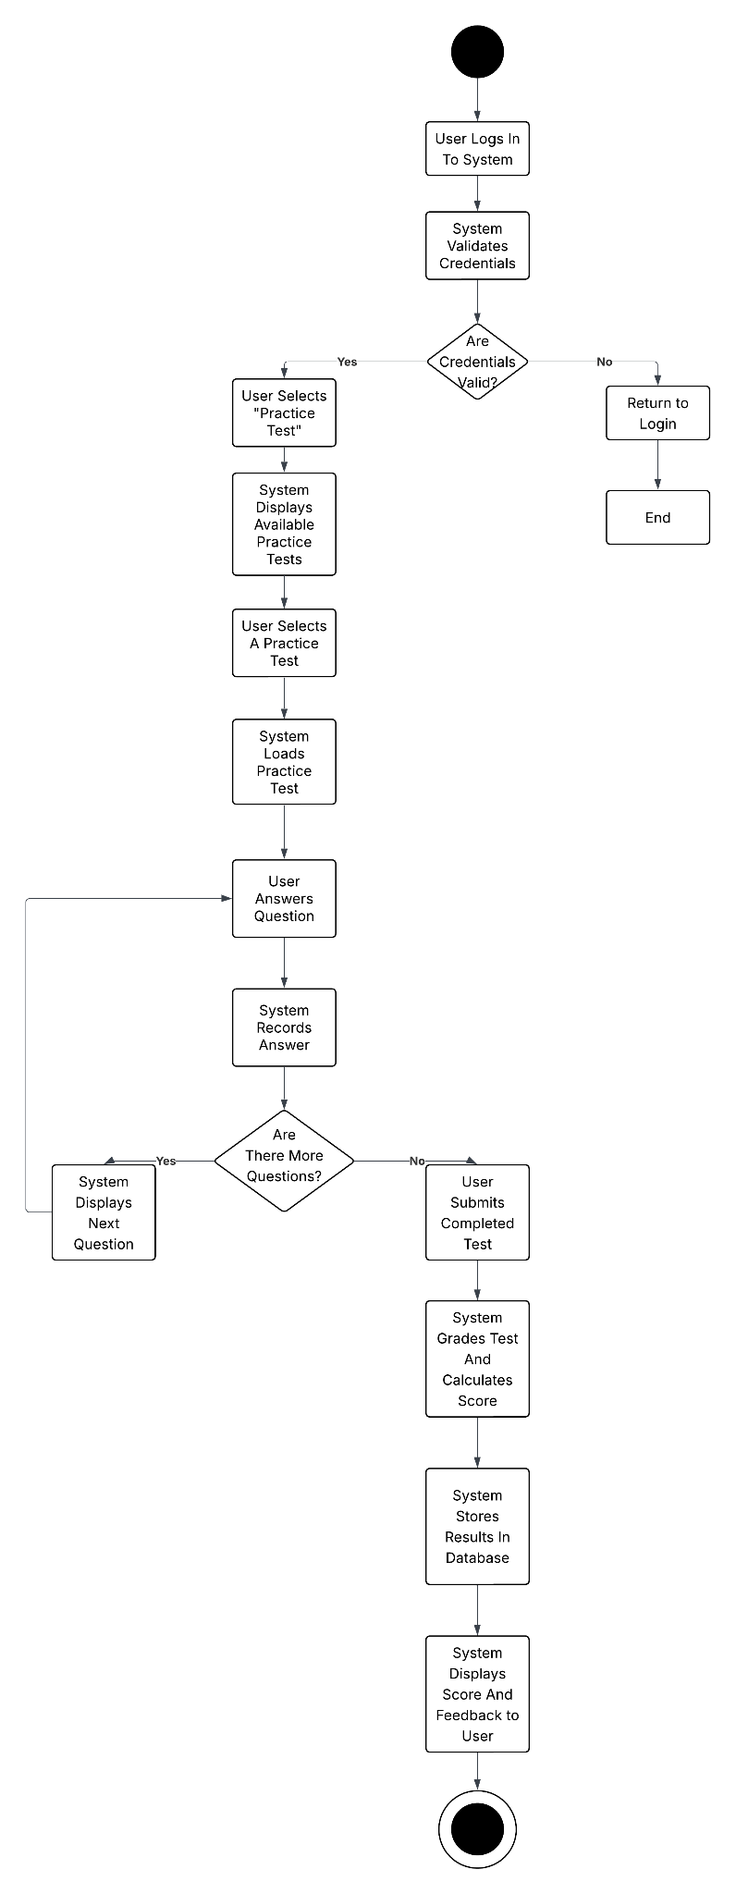

UML Sequence Diagram
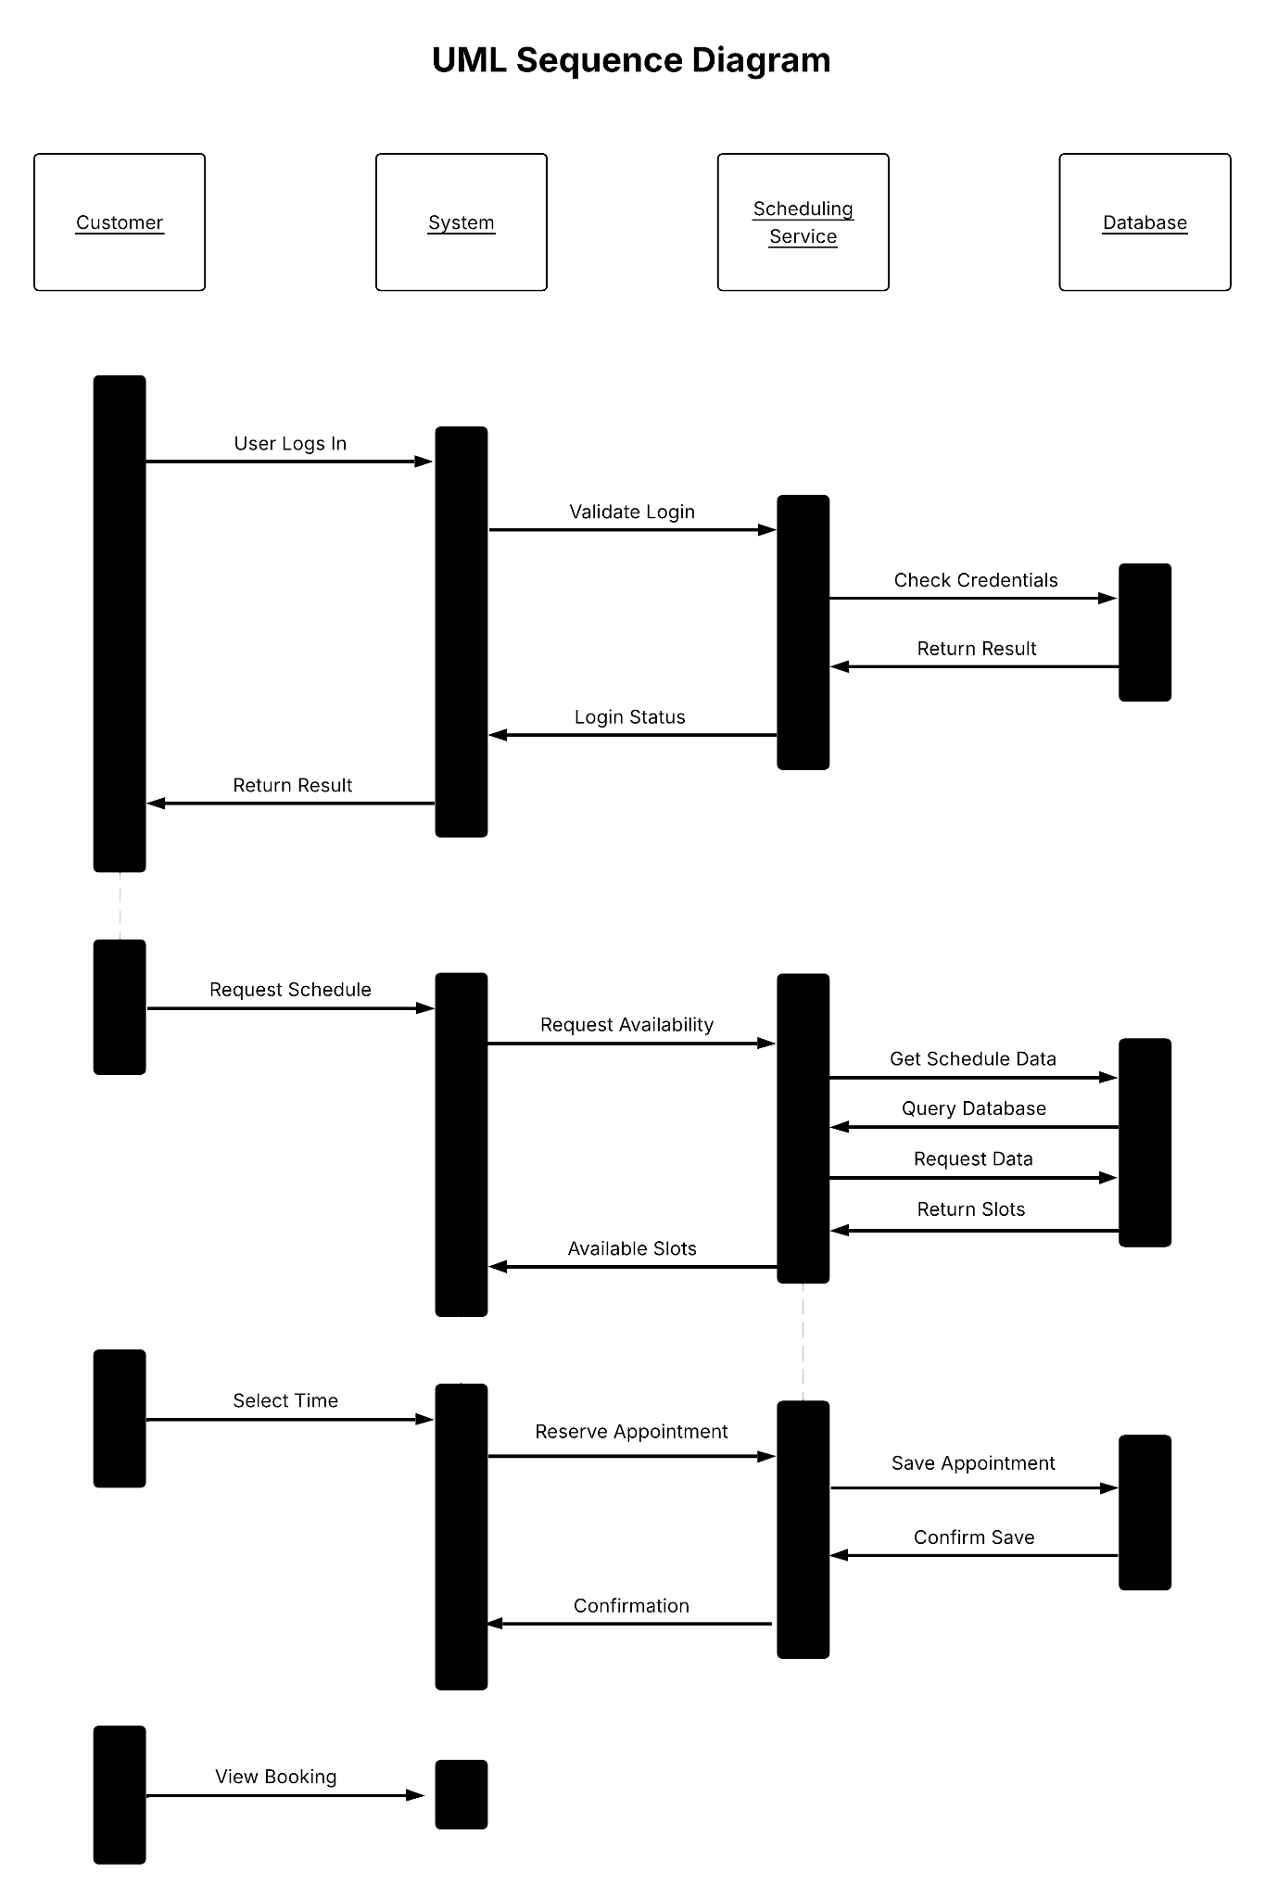

UML Class Diagram
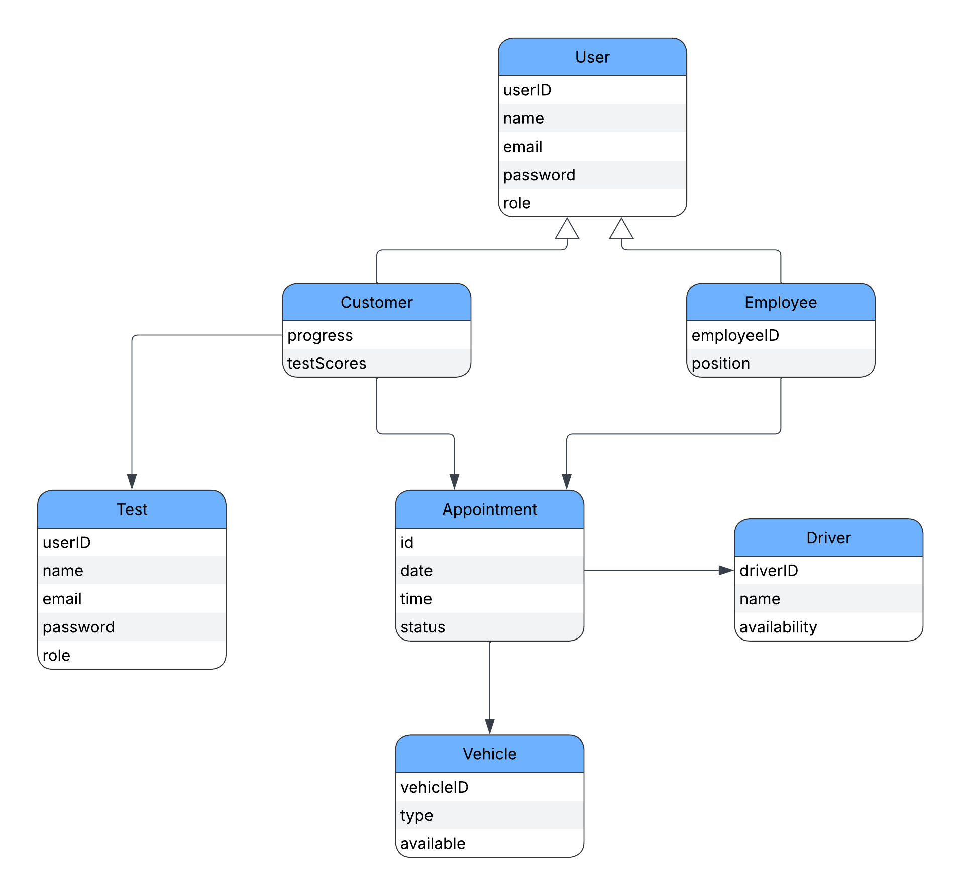

Technical Requirements
The DriverPass system will operate as a web-based application that is accessible through modern web browsers such as Chrome, Edge, and Safari. This allows users to access the system from both desktop and mobile devices, making it convenient and flexible. The system will be hosted on a cloud-based platform, which ensures scalability, reliability, and continuous availability for users and staff.
The system will require a database management system to store important information such as user accounts, appointment schedules, test results, and system activity. Secure authentication mechanisms will be used, including encrypted passwords and role-based access control, to protect sensitive user data.
In terms of hardware, users will need an internet-enabled device, while administrators may require systems capable of handling data management and reporting. The system will also integrate with external DMV services to ensure that training materials and test content remain current and accurate.
Development and design tools such as Lucidchart will be used to create system models, and standard programming frameworks will be used to build and maintain the system. The overall infrastructure will support multiple users at the same time while maintaining performance and security.

